Meta Description:
Is your business failing to deliver exceptional results regarding leads & sales? Learn how to get in touch with the top digital marketing agency in Dubai.
Top Digital Marketing Agency in Dubai | Increase Leads & Sales
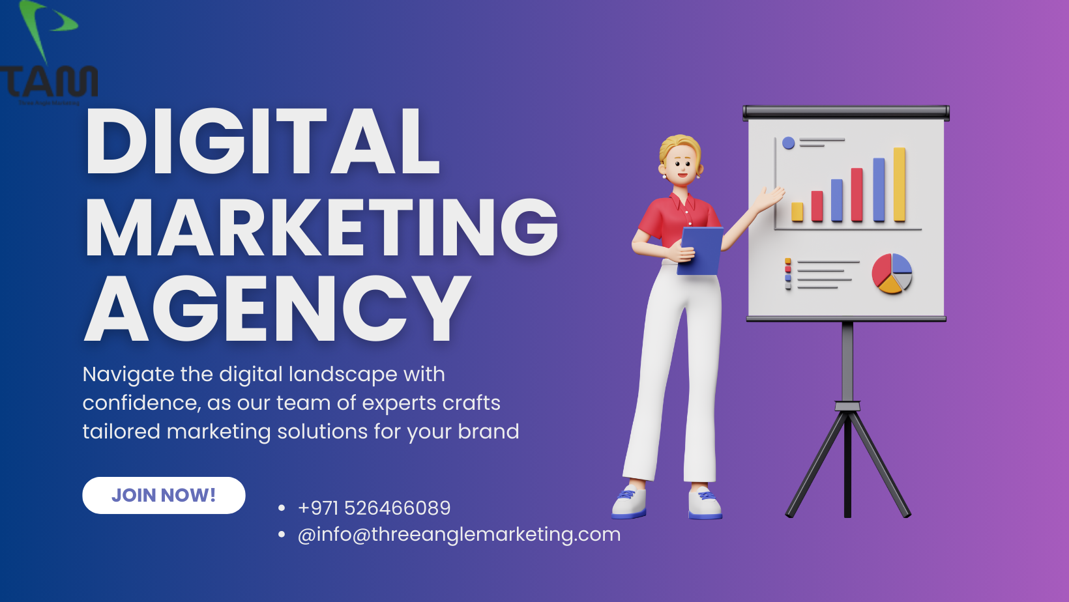
Dubai, as a global business hub, offers a fertile ground for brands of different industries to flourish. With the right digital marketing agency, any brand can greatly improve its business through higher visibility, more leads, and enhanced sales.
In this blog, we are going to discuss digital marketing agencies in Dubai, an analysis of the most important features and the services they provide, and how they adapt their strategies to the local market.
Additionally, we will also look into the methodology of determining the success and some guidelines for selecting the right Digital Marketing Agency in Dubai.

Characteristics of Leading Digital Marketing Agencies in Dubai:
There are numerous unique characteristics that set up the leading digital marketing agencies in Dubai apart from the rest of the competitors. Such characteristics include:
- First, a digital marketing company Dubai has a rationale in terms of demonstrating that it can work across many industries and demonstrate success in different economic environments.
- They are professionals in new age digital marketing providing the firms with insights on the latest trends.
- Another point touched upon is a strong portfolio as the matters in question illustrate previous successes with the clients.
- Also, they can communicate in multiple languages due to the rich demographic structure of Dubai and address a large number of people.

Key Services Offered by Top Digital Marketing Agencies:
Here are some of the most prominent digital marketing services offered by major online marketing agencies in Dubai:

Search Engine Optimization (SEO):
The general perception of the importance of SEO is widely recognized in Dubai and it entails increasing a website’s visibility to attract more traffic. The top agencies know the specificities of SEO and implement diverse practices to enhance the website's ranking on search engine positions.
The major components that agencies work in the field of SEO include keyword implementation, backlinks, and other technical aspects. This SEO optimization ultimately increased the volume of traffic from the organic search for its website, and increased conversion rates.

Pay-Per-Click (PPC) Advertising:
PPC advertising offers organizations a unique marketing opportunity. Through PPC advertising, brands can now select the potential customers in the market without guessing. Usually, this method involves paying for the number of clicks that are usually directed to the various websites of the companies in question.
Most agencies use PPC to drive up their sales as they develop effective advertising campaigns that capture prospective customers. Some examples indicate that PPC has played a crucial role in boosting sales as well as attracting the specific target market.

Social Media Marketing (SMM):
Social media in Dubai is progressively developed in recent times due to the emergence of popular social networks such as Instagram, Facebook, and LinkedIn. While struggling to sustain, most agencies don’t want to lag behind on trends that’s why they are capable of developing astonishing campaigns to generate leads.
For instance, popular strategies for SMM contain working with popular users, the use of interesting content, and the post posts that can stimulate reposting.

Content Marketing Strategies:
Lead generation is a crucial activity in the business world and quality information holds great significance when it comes to the lead generation exercise.
Prominent organizations today pay considerable attention to the information that is presented to the audience about their brand or product.
Some of the common tools of content campaigns include blogging, videos, infographics, White papers, and many others. This is one of the many strategies that are employed to try and touch the hearts of the listeners in one way or another.

Email Marketing:
Email marketing campaigns are one of the most effective forms of communication when it comes to dealing with the leads.
Most successful marketing companies design their email advertisements to fit the tastes of the targeted audiences.
The experiences of businesses and use of email marketing show that the communication method is an effective way to engage audiences, convince them to make purchases and consume products from an organization and generate sales.

How Top Digital Agencies Tailor Strategies to Meet Local Market Needs?
It is imperative to understand some of the cultural peculiarities and the consumers’ behavior in Dubai. So, it is essential for every Digital Marketing Agency in Dubai to spend time on local culture and trends that prevail in a particular country, state or region.
- Marketing campaigns should include the concept of localization, which means that the identified content has to fit the specific locality.
- Some of the clearly defined strategies that can produce high ROI include: Advertising campaigns, Cultural appeals, and Local offers.

Metrics Used to Measure Success:
There are fundamental KPIs that will help measure the effectiveness of digital marketing strategies.
- Lead generation metrics, which include the number of leads and cost per lead, give marketers an indication of the success of the different marketing activities.
- Conversion rates and ROI are other important factors that are mainly used in measuring the full impact of marketing on the financial front.
- Most agencies have an online mapping system which reports success to clients with well-detailed analytics and a periodical follow-up.

How to Choose the Right Digital Marketing Agency in Dubai?
The process of how to choose a digital marketing agency is quite a complicated one since there are numerous things that must be considered. Different clients and customers would indeed benefit from evaluating the agency on the grounds of experience, prior successes and failures, and commonly accepted knowledge of the market landscape. There are some of the questions that should be asked concerning the agency with regard to strategy formulation, measuring success and reporting. Hence, there is a need to maintain a congruity or consistency concerning the business objectives and the organizational culture. Because of these features, it becomes possible for businesses to make a good decision on which agency to work with so as to enhance development.

Conclusion:
In conclusion, here we emphasize the fact that selecting an appropriate digital marketing agency in Dubai can influence a business’s success greatly. Most of the agencies provide website promotion services such as SEO, PPC, SMM, and content marketing services that fit the local market. By knowing the basic peculiarities of top agencies, the main services that they provide, and the way they work, businesses can make the right choices.
With the help of the right agency, the companies in Dubai can improve their online visibility, generate leads and sales, paving the way for sustainable development.

